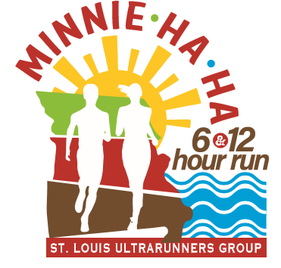
MINNIE HA HA OCTOBER 15, 2022

Hello all and welcome to the 3rd annual Minnie HA HA 6 & 12-Hour Run. We are excited that you have decided to spend your day with us, the awesome SLUG volunteers and the pavement… loop after loop after loop! Our expectation is that this race will be another example of the quality of races that the SLUGS put on and hopeful it’ll be a great event for you!

By the way…. If you’re not a SLUG member talk to me or one of the volunteers at the race… a SLUG membership will save you a bunch of dough at our annual SLUG sponsored races, enrollment in our Eastern Missouri Ultra Series (EMUS), quarterly meetings, a cool holiday party, as well as being able to give back through volunteering to the sport that we all love.

The Fine Print - Details you need to know about the race Saturday 10/15/22
- Packet pickup will be Friday 10/14/22 at the Minnie HA HA race location shelter “E” at the end of the park from 5-7pm and race morning starting at 5:45am…. come Friday and familiarize yourself with the course… I’m pretty sure you won’t get lost on the loop!
- Most important thing to runners: Restrooms – 2 primitives… at start/finish area
and 2 just after the first road crossing on your right side.
- The course does not have any lighting. You may need some sort of headlamp/light for the start of the race and also for the end of the 12-hour race… or you can wing it and mooch off other runners.
- Road Crossing – 2 - one about ½ way point and one close to the start finish area. The Park is still open to other folks so PLEASE PLEASE exercise caution at these crossings… seriously…. we really don’t want make any 911 calls on Saturday!
- Parking – You can park in any of the parking lots. You cannot park on the road/ grass/dirt/playground etc. as you may be ticketed…. which is on you!
- Loop – 1.17-mile USATF certified loop course. The last 20 minutes will be a .47 certified USATF out and back. You will get credited for each fully completed out and back. partials distance will not be counted.
- This is a cup less race. I would recommend that you carry a hand held, vest, etc.
- Drop bag/supplies/camp area – all of your personal stuff needs to be past the start finish line and off the paved course.
- Aid station – 1 aid station just past the start finish area – will be stocked with the usual
SLUG ultra-cuisine…. salty snacks, cookies, candy PPJ sandwiches, boiled potatoes & salt etc. We’ll also have water, soda & Tailwind Nutrition Drink.
- BBQ/Awards – There will a bbq & awards time after both races so stick around and grab something to eat.
- Bring your family and friends for support and to cheer you on! There is a playground at the start finish area. You can also have them join you for some laps… but no bikes, skateboards, scooters, strollers, pets etc.
- The most important thing is to have fun, run hard and enjoy the day!

- Let me know if you have any questions!

Thanks Phil Marra – Your Host & RD – Minnie Ha Ha 6- & 12-Hour Run

